**MCQ**

**Module 3 – OOSAD using UML  
Chapter 09: Object Interaction**

[The correct answer for each question is indicated by BOLD FACE and red color]

**Question 1:** Which of the following is true?

1. spacerIdentifying what messages are passed between objects is a straightforward process.
2. **Message passing is a metaphor used to describe object interaction.**
3. Message passing is only concerned with query operations.

**Question 2:** Which of the following is true about boundary objects?

1. spacerThe identification and specification of boundary objects is purely a design activity.
2. The identification and detailed specification of boundary objects is part of requirements specification.
3. **The identification and specification of boundary objects is considered in both analysis and design but in different ways.**

**Question 3:** What is meant by the term collaboration in context of interaction modelling?

1. spacerA collaboration describes the messages between objects.
2. A collaboration describes objects that share functionality.
3. **A collaboration describes the structure and links between a groups of instances playing roles in a behavior.**

**Question 4:** What is meant by the term interaction?

1. spacerAn interaction describes any communication between two lifelines.
2. An interaction describes a group of lifelines that share functionality.
3. **An interaction defines the message passing between lifelines (e.g. objects) within the context of a collaboration to achieve a particular behavior.**

**Question 5:** An interaction sequence diagram drawn during analysis differs from one drawn during design in which of the following ways?

1. **spacerThe former normally does not include design objects or detailed specifications of message signatures.**
2. The former normally does not include boundary objects.
3. The former normally does not include control objects.

Question 6: On the following figure which of the symbols labelled 1, 2 or 3 represents an activation on a sequence diagram?

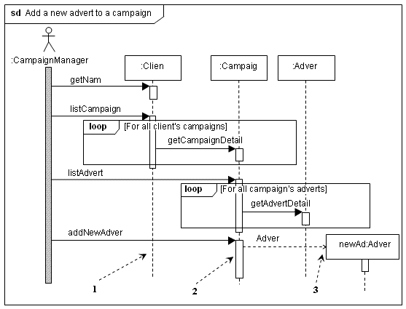

1. spacerSymbol 1
2. **Symbol 2**
3. Symbol 3

**Question 7:** Which of the arrows labelled 1, 2 or 3 is pointing to an interaction constraint? 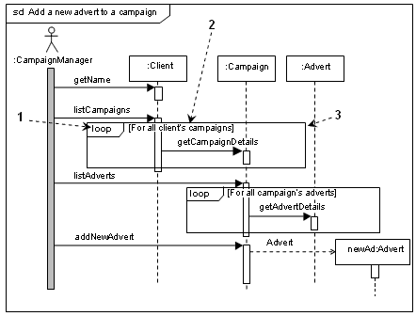spacer

1. Arrow 1
2. **Arrow 2**
3. Arrow 3

**Question 8:** Which of the labelled symbols in the following diagram represents a synchronous message? 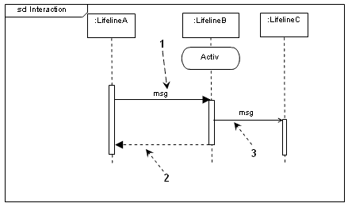

1. **spacerSymbol 1**
2. Symbol 2
3. Symbol 3

**Question 9:** What is meant by the term ‘thread of control’ in the context of concurrent behavior?

1. spacerA thread of control is a weak part of the control system.
2. A thread of control is the mechanism that controls concurrent behavior.
3. **A thread of control is an execution pathway that may occur simultaneously with other execution pathways.**

**Question 10:** Which of the following statements about sequence diagrams is true?

1. spacerA sequence diagram containing an interaction fragment may be referenced by only one sequence diagram.
2. **A sequence diagram containing an interaction fragment may be referenced by one or more sequence diagrams.**
3. A sequence diagram containing an interaction fragment may never be referenced by another sequence diagram.

**Question 11:** Which of the following is an appropriate way of hiding complex behavior in an interaction sequence diagram?

1. **spacerA group of objects and their interactions can be represented by a single lifeline which references an interaction fragment.**
2. Some messages are omitted to reduce the complexity.
3. Some objects are omitted from the diagram to reduce the complexity.

**Question 12:** Which of the following is an appropriate way of modelling a part of an interaction that appears in several other interactions?

1. spacerModel the common part of the interaction as an ‘alt’ combined fragment.
2. Model the common part of the interaction using a communication diagram.
3. **Model the common part of the interaction as an interaction fragment in a separate sequence diagram.**

**Question 13:** Interaction sequence diagrams should be consistent with other diagrams and models that relate to the same group of objects or subsystems. Which of the following statements is true?

1. spacerA sequence diagram must show all the messages that are consistent with the state machines for each of the lifelines in the sequence diagram and be consistent with the class diagram.
2. A sequence diagram must be consistent with the class diagram or with the state machines for lifelines in the sequence diagram.
3. **A sequence diagram must be consistent all other diagrams or models that include or relate to the lifelines in the sequence diagram.**

**Question 14:** Which of the following accurately describes an asynchronous message?

1. **spacerAn asynchronous message does not cause the invoking operation to halt execution while it awaits the return of control.**
2. An asynchronous message has the same effect as a blocking call.
3. An asynchronous message is a reply to a synchronous message.

**Question 15:** Communication diagrams differ from interaction sequence diagrams in the following way?

1. spacerCommunication diagrams cannot show the design detail that can be shown on a sequence diagram.
2. Communication diagrams only show the collaboration and not the sequence of the messages.
3. **Communication diagrams show the links between the objects.**

**Question 16:** In a communication diagram one message has the sequence number 5.1.1. Which of the following sequence numbers indicates the message that must be the immediate successor?

1. spacerA message with the sequence number 5.1.2.
2. **A message with the sequence number 5.1.1.1.**
3. A message with the sequence number 5.2.1.

**Question 17:** Which of the following is a disadvantage of communication diagrams?

1. spacerA communication diagram can only be used during analysis.
2. A communication diagram cannot include guard conditions.
3. **A communication diagram is difficult to read if there are many messages between two objects.**

**Question 18:** An interaction diagram should be consistent with the associated class diagram in various ways. Which of the following statements is true?

1. spacerIt is always correct to show a message between two objects if there is an association between their classes.
2. **The sending object must have the object reference of the receiving object before sending a message to that object.**
3. A message should not be shown between two objects if there is no association between their classes.

spacer

**Question 19:** Which of the following statements is correct about interaction overview diagrams?

1. spacerAn interaction overview diagram may not have decision nodes.
2. An interaction overview diagram may only have interaction occurrences, initial pseudostates and final pseudostates as nodes in the diagram.
3. **An interaction overview diagram may include in-line sequence diagrams.**

**Question 20:** Timing diagrams are used to show how timing constraints affect interactions between lifelines. Which of the following statements is true?

1. spacerA lifeline may only have two alternative states.
2. **When a state change is being modelled that takes significant (from the application’s perspective) time it is shown by a slanting line.**
3. Messages are not shown on timing diagrams.